|  |
| --- |
| HANOI-APTECH - CLASS C1712H |
| FINAL PROJECT : JAVA |
| SUBJECT : MANAGEMENT BUBBLE TEA BILL |
| |  | | --- | | Student  Phạm Ngọc Chiển  Ngô Đức Anh  Lê Việt Dũng |   **Introduction**  Nowadays use of computers is the best to manage the large amount of bills easily and effectively.  And hence looking at the situation at the store, the owner of the shop has decided to move a step ahead and make use of computer to maintain the bill. At the same time he has also thought of expanding the products in the stores. He has thought of development of Bill Management System which will store all the information and required data can be retrieved with ease. We are expected to develop a ‘Bill Management System’ for bubble tea so that users can manage the details.  Recording a hand-written order can lead to errors such as misleading or mistake order, time consuming during peak customer hours. Similar to handwritten invoices, writing the invoices manually will not create a professional impression for the customer and take time when the employee has just ordered to the kitchen and has to return to the new customer with the café tea and milk management software, the restaurant synchronizes all devices to allow employees to record orders on modern mobile devices such as phones and tablets …. Thus , when the employees has just performed the order recording ,at the same the kitchen printer or screen will record and display the order request cut service time by up to 50% and minimize the smallest errors . |

Contents

FINAL PROJECT 4

1. Purpose: 4

2. Main function 4

2.1 Inventory management 4

2.2 Order 5

2.3 Total Bill 5

3. DESIGN 6

3.1 DFD 6

3.2 Database design 6

3.3 Database structures 6

3.3.1 Table customer 6

3.3.2 Table employee 7

3.3.3 Table product 7

3.3.4 Table bill 7

3.3.5 Table invoice 8

4. Instruction 8

4.1 For user 8

4.2 For developer 8

Last words 8

# FINAL PROJECT

# Purpose:

|  |
| --- |
|  |

* The program is built in JAVA language, with the aim of supporting the sale of soft drinks, helping to save time for employees and managers.
* Personnel are managed through employee profile information including: name, address, phone number.
* Warehouse is managed by list with data: product’s name, price.

# Main function

## Inventory management

**2.1.1.** Employee Management:

* + Add the information of the Employee:
    - Input: Name, Sex of the employee
    - Action: Insert
    - Output: Show message
  + Edit exist information of the Employee:
    - Input: ID, Name, Sex.
    - Action: Edit
    - Output: Show message
  + Delete the information of the Employee when he/she no longer works:
    - Input: ID
    - Output: Show message
  + Show all Employees.

**2.1.2.** Customer Management:

* + Add the information of the Customer:
    - Input: Name, Address and Tel
    - Action: Insert
    - Output: Show message
  + Edit exist information of the Customer.
    - Input: ID, Name, Address and Tel
    - Action: Edit
    - Output: Show message
  + Delete the information of the Customer.
    - Input: ID
    - Action: Delete
    - Output: Show message
  + Show all Customers.

**2.1.3.** Product Management:

* + Add the product information:
    - Input: Name, Price
    - Action: Insert
    - Output: Show message
  + Edit the existed product.
    - Input: ID, Name, Price
    - Action: Edit
    - Output: Show message
  + Delete product.
    - Input: ID
    - Action: Delete
    - Output: Show message
  + Display products.

## Order

* First you must input your Employee ID.
* Then input customer information. If the customer is ordering online, you must input those or else the items can’t be shipped to the customer. If the customer is ordering directly, you can just input null to the field.
* Then, list of bubble teas show up to help the customer choose the desired item.
* Choosing item: can choose item, quantity and add topping or not.
* Can insert to bill and print out multiple items per customer.

## Total Bill

* Show each bill details via invoice ID
* Show all bill

# DESIGN

## DFD

Level 0:

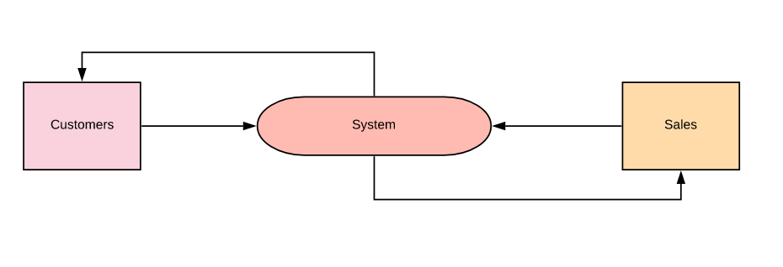

Level 1:

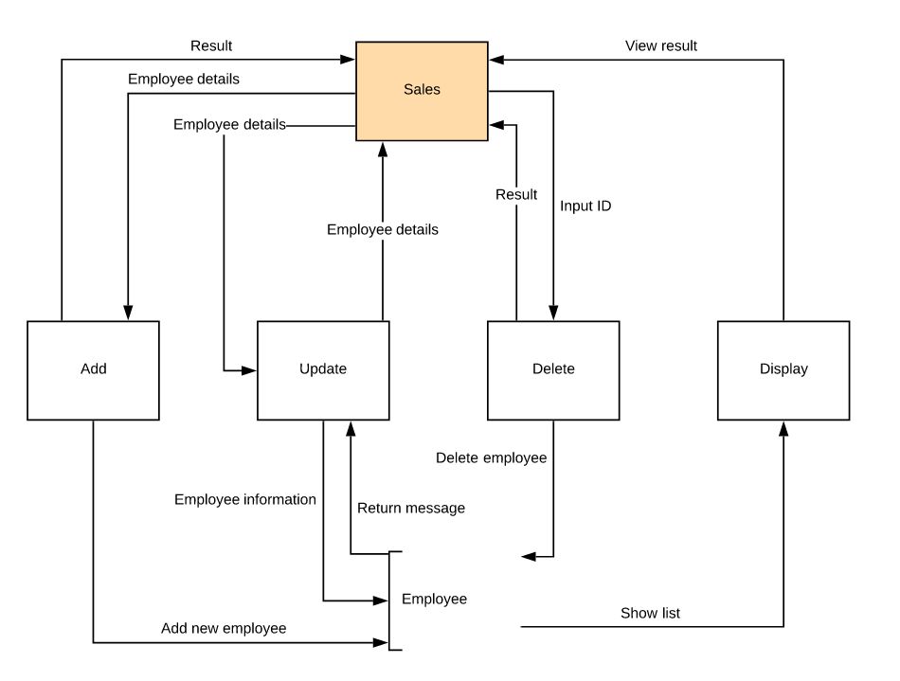

Employee

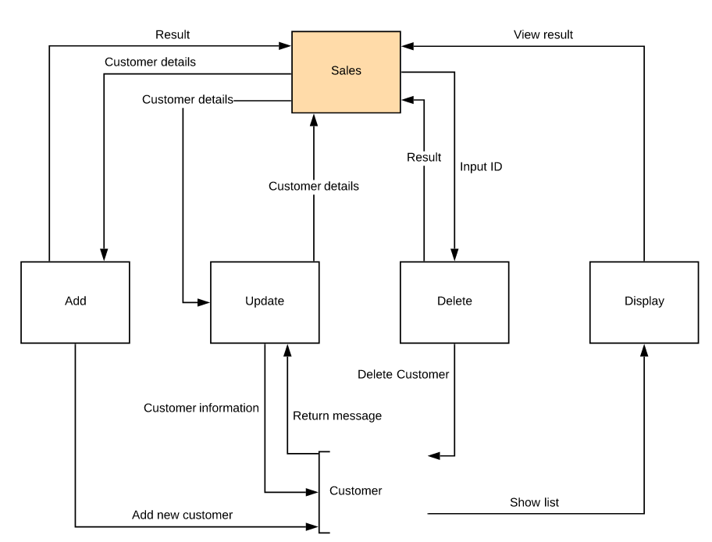

Customer

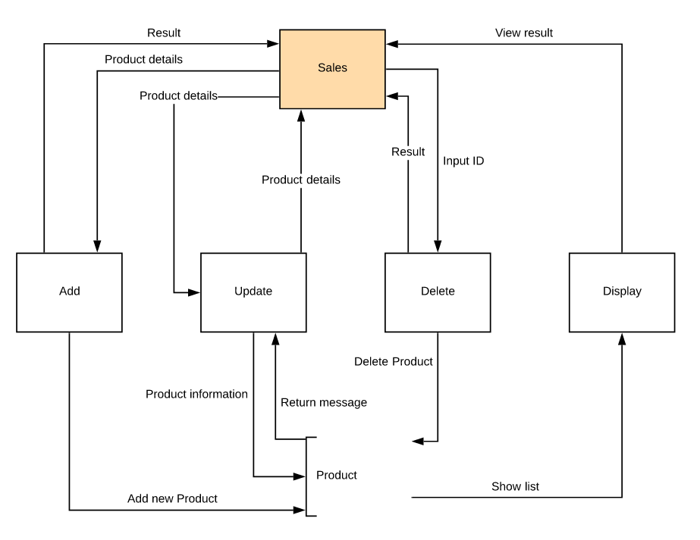

Product

Level 2:

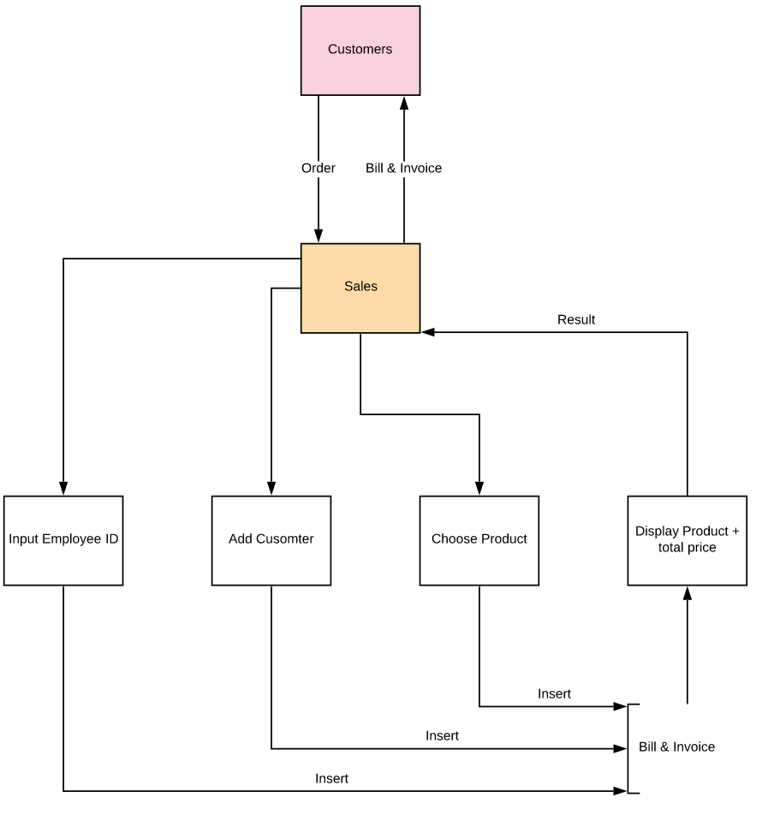

## Database design

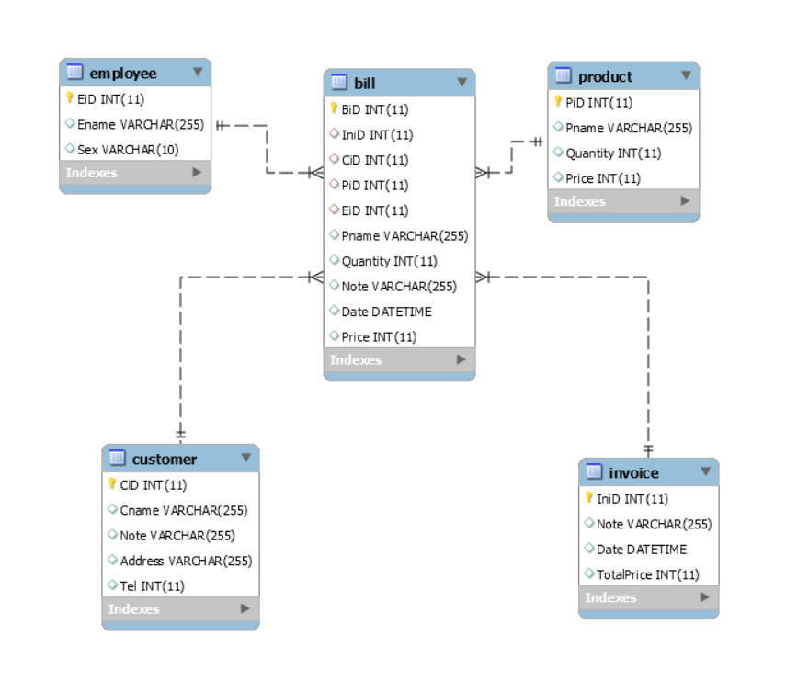

## Database structures

### Table customer

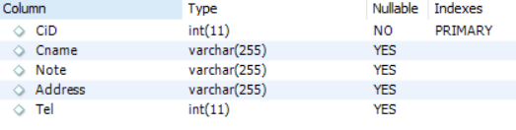

### Table employee

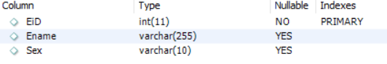

### Table product

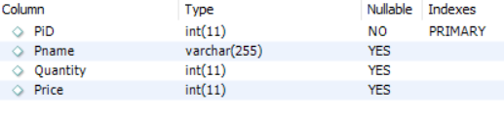

### Table bill

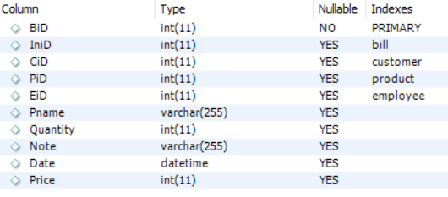

### Table invoice

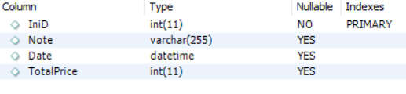

# Instruction

## For user

* Easy to use
* Start the program
* Choose the option you want
* And then input using number
* For further details, please see the guides.

## For developer

* Functions are divided into packages with the name of the job that it will do.
* Also, there are notes in each package to show the job of each section in the package

# Last words

Final project are many shortcomings, we hope to see the teacher review and comments with the team.

Sincerely thank you.